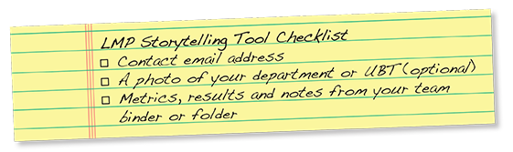

Tell your story
Fill out this form to create an animated story. Craft your story with your co-lead or teammates or create it by yourself. You might want to keep your team’s binder on hand to remind you of critical details. Be sure to complete the starter sentences provided; the full sentences will appear in the animated version. Please be courteous—and don’t include any protected (HIPAA) or proprietary information. Keep your responses short (about 100-200 words), but use some details to make your story come alive. Tell why your team took the actions it did.

Once upon a time…
Introduce your story; set the stage.
Create a title for your story:
Insert Story Title
This is the story of the Name of Department/Unit-based Team
at Insert name of facility
in Insert name of region .

What vehicle would you like to take on your journey?
SUV Sports Car Hybrid

Our team’s job is to…
(Enter a short description of how your department or unit serves KP patients, members and/or employees.
If you have a mission statement, this is a good place to include it. Please use full sentences. Maximum word count: 30)

Describe your team's job or mission statement here

Suddenly…
What challenges did your team face?

Our team wanted to make things better for our KP patients and members, so we…
(Enter a short description of the problem you set out to solve and why you chose it. Please use full sentences.
Maximum word count: 30)

Describe team challenges here

Our test of change addressed this point on the Value Compass (pick the main one):
Best quality
Most affordable
Best place to work
Best service

First we needed to test out our change, so…
(Enter a short explanation of your test of change and who did what to carry it out. If you had to work with another department to get this done, this is a good place to mention it. Maximum word count: 200)

Explain your test of change here

In order to know if we were making progress toward our goal, we needed data, so we…
(Explain how you measured your test. Maximum word count: 200)

Explain how your test was measured here

And then…
What steps did your team take to address the challenge?
When team members looked at the numbers, we saw that we had…
(Explain your results and how you knew that they were an improvement. Maximum word count: 200)

Explain your results here

The people we serve were happier because…
(Explain how you measured your test. Maximum word count: 200)

Explain how you measured your test here

Along the way our UBT faced some obstacles. To overcome them we…
(Explain any challenges you faced and what you did to rise above them. Maximum word count: 200)

Explain the challenges here

Our biggest challenge involved (choose the closest one):

Communication Choosing the right measurement
Distrust Getting buy-in
Choosing a test of change Making group decisions

Happily ever after…
What steps did your team take to address the challenge?
We learned more than we ever expected, including…
(What were the top three things you learned and why? Maximum word count: 200)

List the top three things you learned

Most of all, things will never be the same since we undertook this journey because…
(How are you and your department or unit different than before you worked on this test of change? Give specific examples and feel free to call out staff members who either changed the most or went the extra mile to help the whole team succeed. You might want to use quotes. Maximum word count: 200)

Explain how your department has changed here

The End
Please go online to submit your story at:

http://www.lmpartnership.org/storytelling

