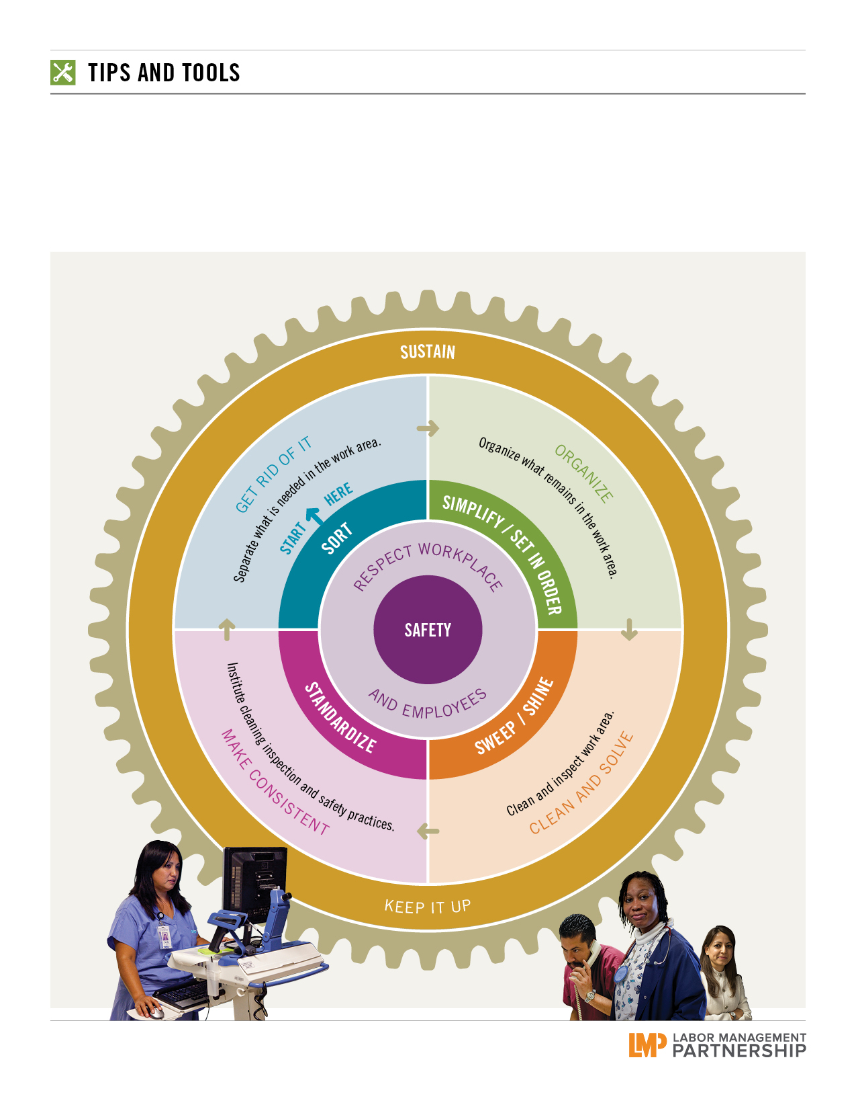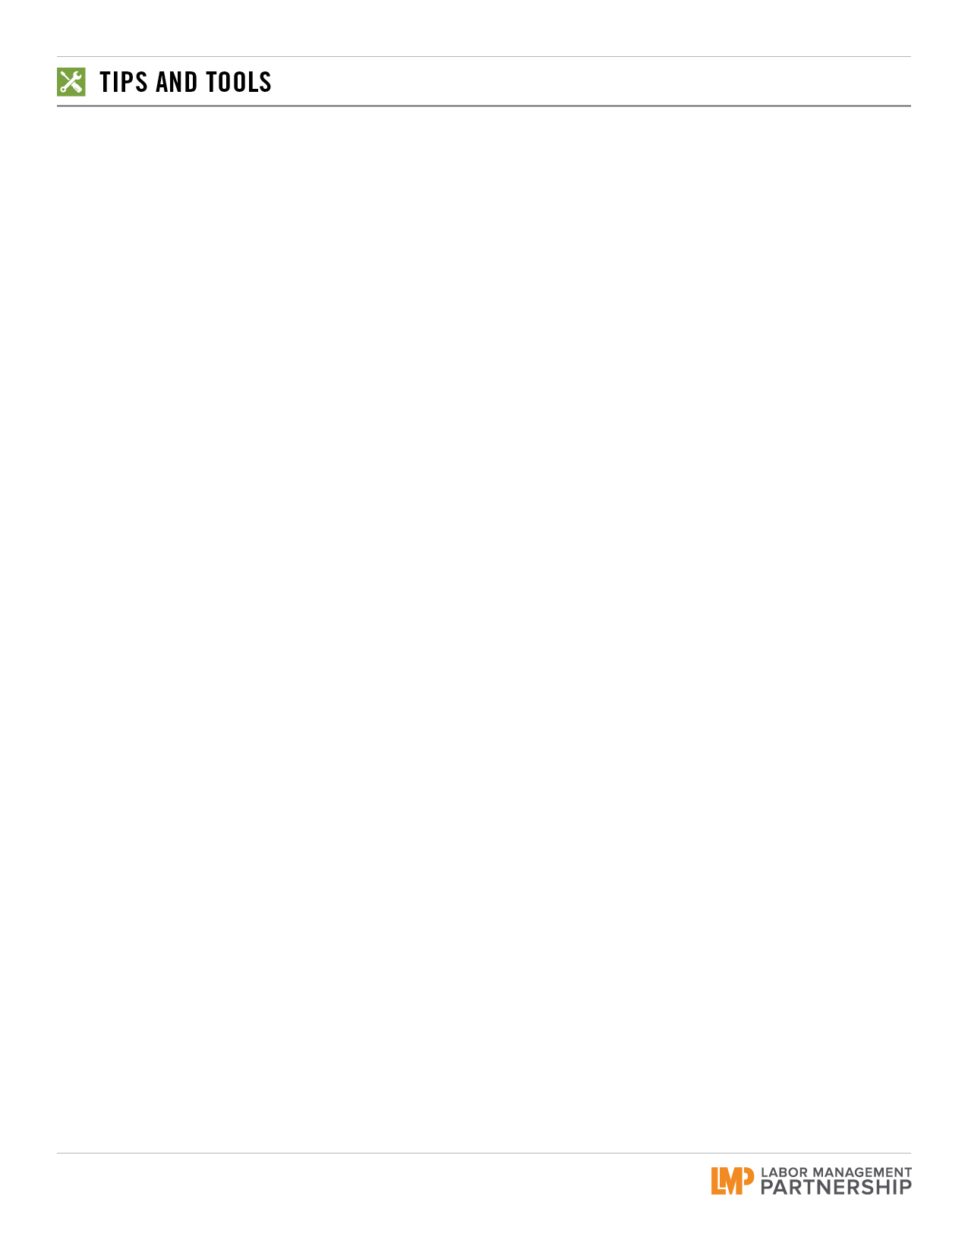

**6S to Tame Chaos in the Workplace**

**Purpose:** Primarily used as a systematic approach to organizing everything from inventory and stock to desktop and computer files.   
Improves inventory control, which helps save Kaiser Permanente money—as well as creating a healthier, happier workplace.

**When:** Use if your supplies are disorganized, or if stock is being hoarded or still on the shelf when the expiration date arrives.

**Who:** Level 2 team and higher. The 6S tool is not complicated and gets everyone on the team involved.

Page **1** / 2

4. **STANDARDIZE**

**GOAL:** **Prevent setbacks in previous three steps.**

[ ] As a team, develop checklists or work instructions.

[ ] Create a shadow board to show where tools and equipment are stored (optional).

[ ] As a team, determine appropriate inventory.

[ ] Consider using “kanban” cards (color-coded cards used to   
signal when to order, what to order, etc.) to identify when   
reordering or replacement is necessary.

[ ] Update policy and procedures manual with new way of   
doing work.

[ ] Communicate with the affected people and departments and   
ask for feedback.

NOTES:

5. **SAFETY**

**GOAL:** **Create a work environment where hazards are easily   
identified and then minimized or eliminated.**

[ ] Are hazardous materials properly labeled and stored?

[ ] Are walkways, aisles and workstations free of clutter?

[ ] Are exits clearly identified?

[ ] Is personal protective equipment available and maintained?

[ ] How are hazards identified and discussed?

NOTES:

6. **SUSTAIN**

**GOAL:** **Setting and maintaining the proper conditions to keep 6S alive and active in the workplace.**

[ ] AWARENESS: Communicate so people know the benefits and the rewards of doing 6S.

[ ] TIME: Build in time to do 6S and have the right people   
doing it.

[ ] STRUCTURE: Make it a part of daily work.

[ ] REWARDS AND RECOGNITION: Create and connect so praise is meaningful and timely.

[ ] Post before and after photos.

NOTES:

1. **SORT**

**GOAL:** **Remove everything from the workplace that is not needed to do the work. Get organized.**

[ ] Take a picture of what the area looks like now.

[ ] Decide who will lead this effort and who will do it.

[ ] Set a deadline for finishing the 6S work.

[ ] Sort items into three categories: keep, decide and trash/recycle.

[ ] Once items are sorted, get feedback from all affected employees and departments.

[ ] See if items in trash/recycle can be donated.

[ ] Take the items from the decide group and place them in the keep or trash/recycle group.

NOTES:

2. **SIMPLIFY / SET IN ORDER**

**GOAL:** **A place for everything and everything in its place.**

[ ] Organize and establish a place for the “keep” items from the   
Sort step.

[ ] Locate items according to frequency of use, ease of access and ease of use. Try to color code like items.

[ ] Label the location for each item and its quantity.

[ ] Outline with tape the area where equipment will be stored.

[ ] Map the new locations of items and educate employees on the proposed changes. Allow for feedback.

[ ] Use PDSA cycle testing prior to final implementation.

NOTES:

3. **SWEEP / SHINE**

**GOAL:** **A clean and neat workspace or area.**

[ ] Clean area(s) and/or equipment.

[ ] Develop a schedule and checklist to ensure items and/or areas stay clean. Example: What will be done daily, weekly or monthly?Who does what?

[ ] Team determines what cleaning supplies need to be kept on hand.

[ ] Think about who else may be affected (EVS, for example) and involve them if necessary.

NOTES:

Page **2** / 2